**Report No: 1**

**Report Name: Write a stack program with push and pop function.**

**Code:**

#include <bits/stdc++.h>

using namespace std;

int top = -1;

#define size 5

int myArray[size];

// ========FUNCTION DECLEARATION==========

void pushFunction();

void popFunction();

void showFunction();

void endFunction();

void mainFunction();

int main(){

mainFunction();

}

// =========PUSH OPERATION=========

void pushFunction(){

system("cls");

int value;

if(top == size - 1){

cout << "Stack is overflow";

cout << "\nPress any key to continue";

fflush(stdin);

getchar();

main();

}else{

top = top + 1;

cout << "\nEnter " << top << " index element: ";

cin >> value;

myArray[top] = value;

cout << "\nPress any key to continue";

fflush(stdin);

getchar();

main();

}

}

// ============POP OPERATION============

void popFunction(){

system("cls");

int item;

if(top == -1){

cout << "Stack is overflow";

cout << "\nPress any key to continue";

fflush(stdin);

getchar();

main();

}else{

item = myArray[top];

cout << "\n" << item << " Element is deleted successfully & index num: " << top;

top = top - 1;

cout << "\nPress any key to continue";

fflush(stdin);

getchar();

main();

}

}

// ==========SHOW OPERATION==========

void showFunction(){

system("cls");

if(top == -1){

cout << "Stack is overflow";

cout << "\nPress any key to continue";

fflush(stdin);

getchar();

main();

}

for(int i = 0 ; i <= top ; i++){

cout << "\n" << i << " index element is: " << myArray[i];

}

cout << "\nPress any key to continue";

fflush(stdin);

getchar();

main();

}

// ==========END OPERATION==========

void endFunction(){

cout << "Your program is finished";

exit(0);

}

// =========MAINFUNCTION OPERATION=========

void mainFunction(){

system("cls");

int choice;

cout << "1. Insert element (Push)" <<endl;

cout << "2. Deletion element (Pop)" <<endl;

cout << "3. Show Function" <<endl;

cout << "4. End operation" <<endl;

cout << "Choice your option: ";

cin >> choice;

switch (choice)

{

case 1:

pushFunction();

break;

case 2:

popFunction();

break;

case 3:

showFunction();

break;

case 4:

endFunction();

break;

default:

cout << "Something went wrong";

cout << "\nPress any key to continue";

fflush(stdin);

getchar();

main();

}

}

**Output: First interface of program**

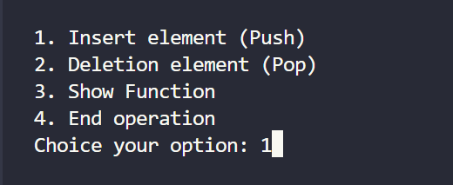

**Output: When we choice option 1 (Push)**

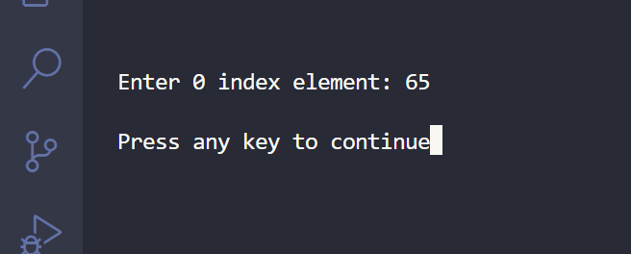

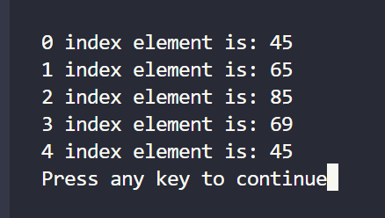**Output: When we choice option 3 (show)**

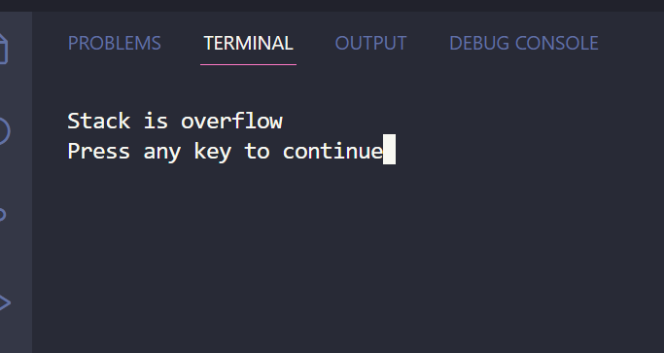**Output: When we choice again option 1 (push)**

**Output: When we choice option 2 (pop)**

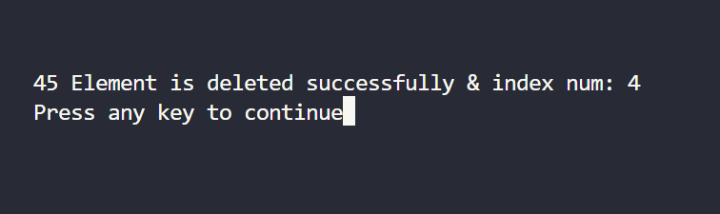

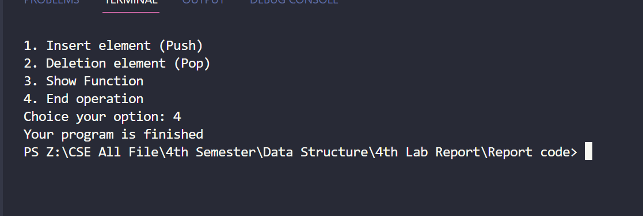**Output: When we choice option 24(end)**